**9) Host a website given below using App Engine standard environment**

<https://github.com/amunategui/rapid-prototyping-app-engine-yelp.git>

Step 1 : Open App Engine and create an application

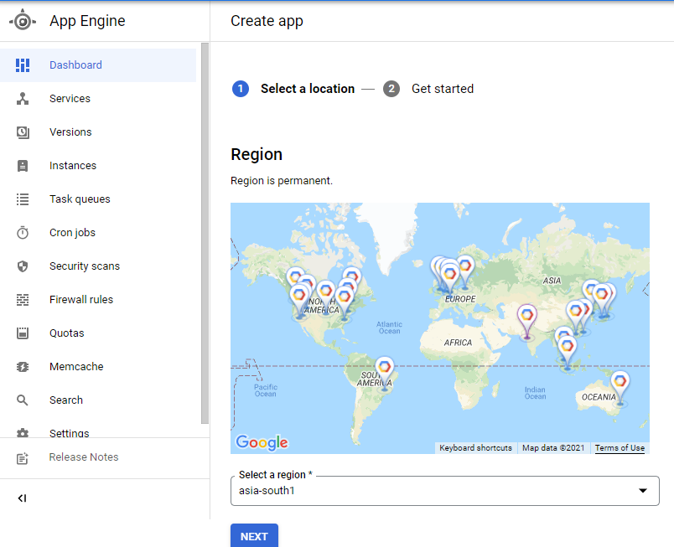

Step 2 : Open cloud shell and install cloud app engine in it

Step 3 : Then clone the required github repository to the shell using git clone command

Step 4 : Go to the path containing all the required files and install requirements.txt

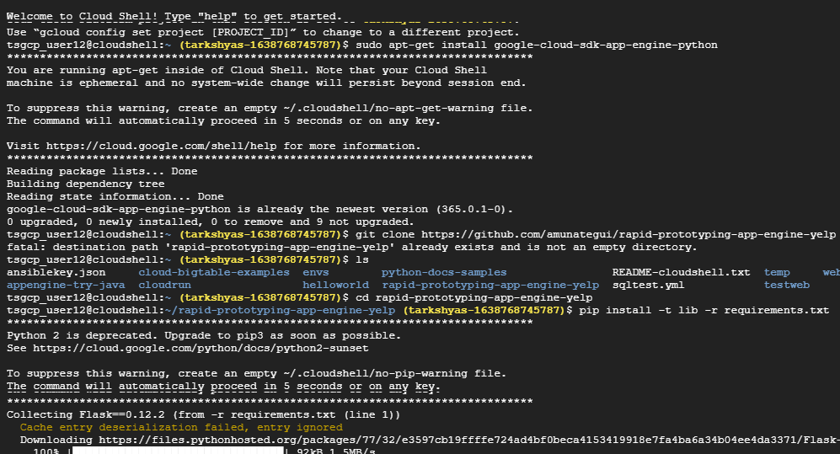

Step 5 : Initiate google cloud by the command gcloud init

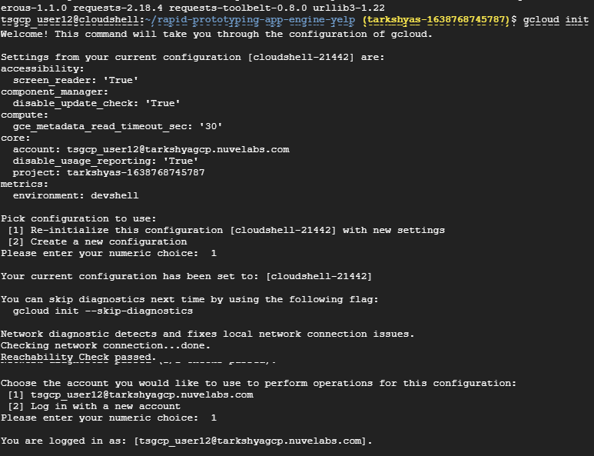

Step 6 : Configure the project and deploy using gcloud app deploy command

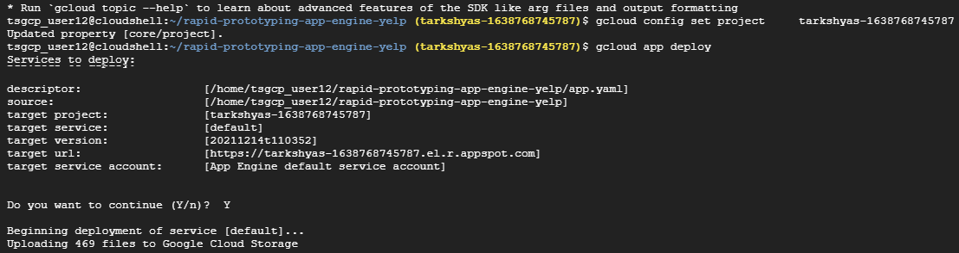

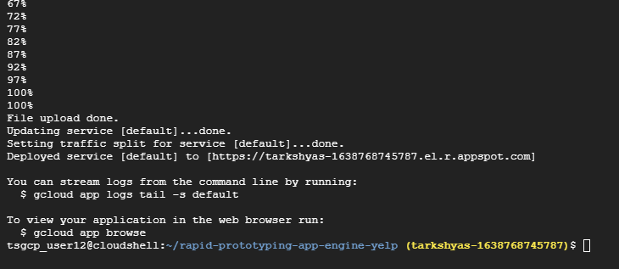

Step 7 : Copy and paste the link generated after deploying. It leads to the particular website created by deploying application using app engine.

